|  |  |  |
| --- | --- | --- |
|  | Bremer State High School | |
| Student name: | |
| Teacher name: | |
| Date handed out: February 24, 2025 | **Draft due**: 24th March 4 pm  Through Tunitin  **Date due:** 24th Appril 9 am  Through Tunitin |

|  |  |
| --- | --- |
| Subject | Mathematical Methods |
| Technique | Problem-solving and Modelling Task |
| Unit 1 | Algebra and functions |
| Topics 1 &2 | quadratic and cubic functions |

**Conditions:**

* Students will use 3 hours of class time and their own time out of class to develop their response.
* This is an individual task.
* Data may be provided or collected individually or collected in groups.
* Appendixes can include raw data, repeated calculations, evidence of authentication and student notes (appendixes are not marked).
* Students must use technology, e.g. scientific calculator, graphics calculator, spreadsheet program and/or other mathematical software; use of technology must go beyond simple computation or word processing.

**Response requirements:**

Written: up to 10 A4 pages, up to 2000 words (excluding appendixes)

|  |
| --- |
| Context |
| Computer-generated images in video games are created using a number of mathematical concepts and techniques, including basic arithmetic, geometry, algebra and calculus.  A computer animation studio is interested in developing its own ‘physical engine’. They have asked you to work on one aspect of the engine-how objects act under influence of gravity. It has been suggested that as a proof of concept, a function can be used to model the path of the stream of water flowing from a hose. |
| Task |
| Consider a stream of water flowing from a hose. Assume that the end of the hose is at ground level, angled upwards, and that the stream of water hits the ground a distance *d*, from the end of the hose.  Use your knowledge of quadratic and cubic functions to develop a mathematical model the shape of the water stream, and then produce a report that explains how you developed and refined your model. |

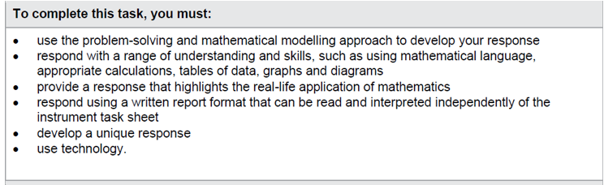

|  |
| --- |
| Checkpoints: |
| One week after issue date: students email evidence of their progress to their teacher. |
| Four weeks after issue: Assessment draft Submit via TurnItIn |
| First Maths lesson of week 1 of term 2 final assessment must be submitted via TurnItIn. |

**Assessment objectives**

1. Recall mathematical knowledge.

2. Use mathematical knowledge.

3. Communicate mathematical knowledge.

4. Evaluate the reasonableness of solutions.

5. Justify procedures and decisions.

6. Solve mathematical problems

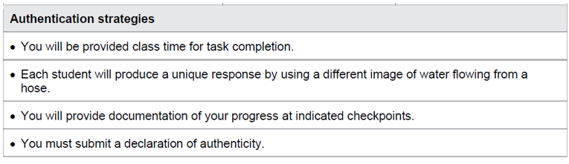

|  |
| --- |
| Scaffolding : |
| The approach to problem solving and mathematical modelling must be used (see below) |

